QTM02 – eProcurement glossary
– Working group

Scope: | eProcurement Ontology
Reference/JIRA: | QTM02
Document type code:
Version: | 010
Version Date: | 2017-11-17
Contract: | 10649 Lot 1
Author: | everis
Filename: | 0000.doc

Change History
Version | Date | Description of action | Pages
010 | 2017-11-17 | Initial version | All

Table of contents
1 Glossary 3
1.1 e-Procurement Glossary - Github 3
1.1.1 Index of terms 3
1.1.2 Linked concepts 3
1.2 Worksheet for the working group 4
1.2.1 Glossary spreadsheet structure 4
1.2.2 Working group actions 7

Figure 1 – Index of terms 3
Figure 2 – Linked concepts 3
Figure 3 – Source 5
Figure 4 – Best Definition Choice 5
Figure 5 - Use Cases 6
Figure 6 - Columns definitions 7
Figure 7 - Name current version 8

Glossary

e-Procurement Glossary - Github
The e-procurement glossary has been set up into Github to support the collaborative work around the development thereof.

Index of terms
The glossary is alphabetical ordered to allow its consultation in an easy and quick way. The index functionality consists in a linked alphabet (each letter is linked to the concepts starting with this letter). The following image shows the glossary index:

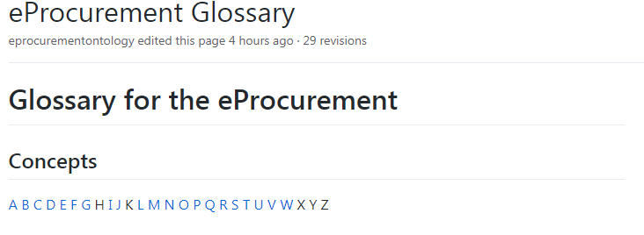
Figure 1 – Index of terms

Linked concepts
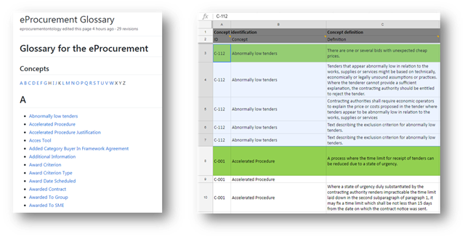
Each of the concepts contained in the glossary is linked to a Google Spreadsheet. Within this spreadsheet, users can see all of the properties and/or characteristics of the selected concept.
Figure 2 – Linked concepts

Each concept contains 1-N rows, each one with a specific definition coming from a specific source.
The use of the glossary spreadsheet will allow the working group members to work in a collaborative way in the development and validation of the glossary. This format, although it is very flexible, requires to take into account some considerations to work in a coordinated way and avoid loss of information at the same time.
The document has restricted access and only members of the working group have edition permissions.
The following sections of this document explain in detail each of the sections of the spreadsheet and how to use it to provide feedback.

Worksheet for the working group

Glossary spreadsheet structure

The spreadsheet collect all the concepts with their main properties. These properties are represented in the following columns:

- ID: the internal identification number to each procurement concept.
- Concept: the name of the concept as it appears in the glossary. Other concepts may be related or depend on it.
- Definition: The meaning of the concept taking into account its application context. There might be more than one definition per concept depending on the source used. Whenever possible, the definitions are literally citing the related source.
- Source (drop-down list): the document or standard where the definition can be found:
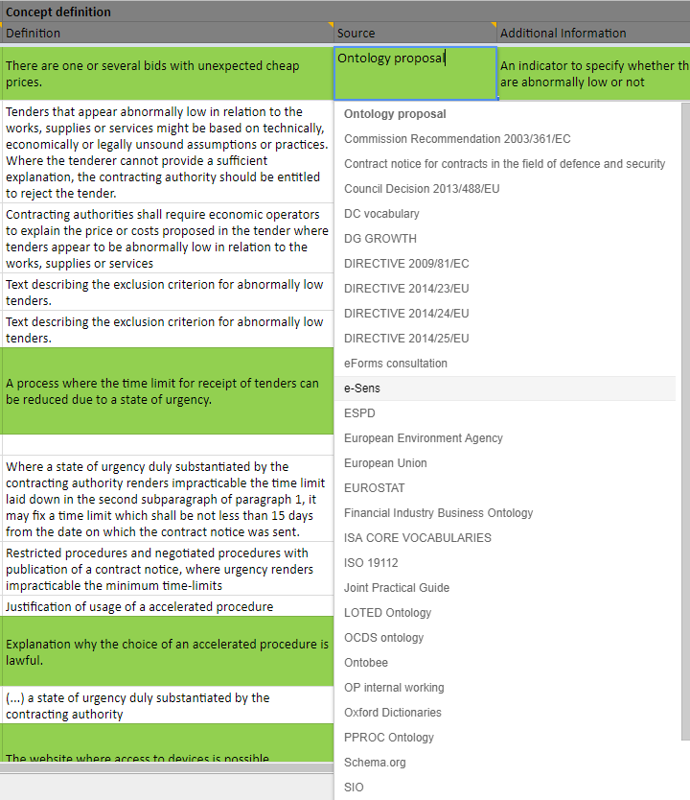
Figure 3 – Source

The list of sources can be also edited to add new ones if required.
- Additional Information: extra information related to the concept. It can be the URL of the source, clarifying notes, or the exact reference of the definition (e.g. a specific article in one directive).
- Choice (drop-down list): of all the concept definitions, only one can be selected as the main one. This choice will be marked with a YES (and highlighted in green) in the spreadsheet.

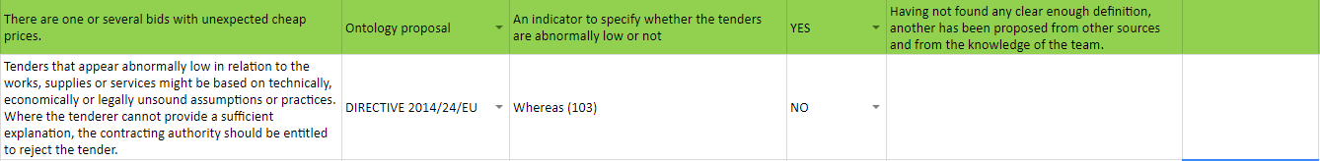
Figure 4 – Best Definition Choice

- Justification: the motivation to choose a specific definition above the rest.
- Comments: a free text column to get feedback about this specific concept definition from the Working Group users.
- Use Cases: these columns mark the relation of the different use case scenarios defined in GitHub with each of the concepts. By the moment, only 3 use cases have been defined:
- UC1 – Data Journalism
- UC2 – Matchmaking of products and business
- UC3 – VAT payment verification

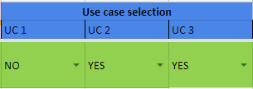
Figure 5 - Use Cases

A concept may be related to 0, 1, 2 or all 3 use cases (dropdown list “YES/NO”). This structure can be extended in the future with more use cases.

- Phases (drop-down list): the relation of each concept with the different phases of the e-Procurement process as defined by the Publications Office of the EU:
- e-Notification (TED): phase related to the publication of the procurement notices involved in the process.
- e-Access (e-Tendering): phase related to the access to all procurement documents and contract information.
- e-Submission: phase related to the submission of tenders or requests to participate in a contract.
- e-Evaluation: phase related to the evaluation of the submitted tenders and its selection and award criterion.
- e-Awarding: phase related to awarding the contract to the supplier.
- e-Request: phase related to how potential suppliers competitively cost the final chosen solution.
- e-Ordering: phase related to the electronic ordering within contracts and framework agreements.
- e-Fulfilment: phase related to the accomplishment of the requirements of the contract.
- e-Invoicing: phase related to the electronic invoicing of products and services.
- e-Payment: phase related to the electronic payment and validation of the issued invoices.
A concept can be linked to any phase (ideally at least 1), or even to all of them if it is a general concept.
All the phase definitions and a picture of the whole e-procurement process are also available as a comments in each column of the spreadsheet.

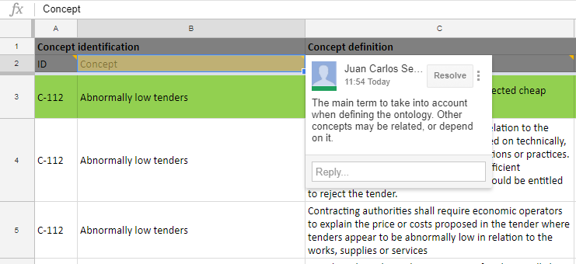
Figure 6 - Columns definitions

Working group actions
The members of the working group are responsible for the edition of the glossary. The users may know who is also working at the same time in the spreadsheet.
The following sections explains what are the tasks to be performed by the working group in order to improve the glossary.

Glossary improvement
The working work can have edition mode to the following columns:
- Comments: The comments column should begin with the name of the user and the date (e.g. [USER1 20171117]). It is very important that each user inputs the name and date in order to have a control of who has edited the concept. Later on all these comments will be revised by the working group coordinator in order to implement the requested changes.
- Uses cases (UC1, UC2, UC3…): Select the different uses cases related to the concept.
- e-Procurement Phases (e-Notifications, e-Access, e-Submission, etc…): Select which e-procurement phases are related to the concept.
Other restricted operations are to be allowed only to the administrators of GitHub and the Glossary spreadsheet. These operations are:
- Create new concept: add a new procurement glossary entry. It must be added both in the glossary spreadsheet and the GitHub glossary wiki.
- Create new definition: add a new row with a concept definition from a specific source. All definitions of the same concept must be placed in consecutive rows to allow readability. Whenever a new definition is added, the range of rows of the concept is also altered so both the named intervals in the spreadsheet and the glossary entry link in the GitHub wiki should be updated.
- Edit the sources: although there is a comprehensive list of procurement definition sources, new ones can still be added (always checking first if there is any redundancy with the existing ones). This requires changing the validation control of all cells from the source column (Data > Data validation)
- Add new Use Case: may a new use case be added in the GitHub, a new column should be added too in the spreadsheet in order to be able to link the different concepts to the new use case.

Versioning system
Google docs saves automatically the document after every change to avoid loss of information. In the event of detecting an issue with the current version, the administrator can restore the spreadsheet to any previous version.
It is proposed to apply the following procedure to have a better control of the versioning system: each time a user finishes editing the document, the name of the version must be edited by entering the author's name, date and version number (e.g. User1_20171117_v145.1).
Major versions of the document can also be marked with a change of the main version numbering (1.14 => 2.0).

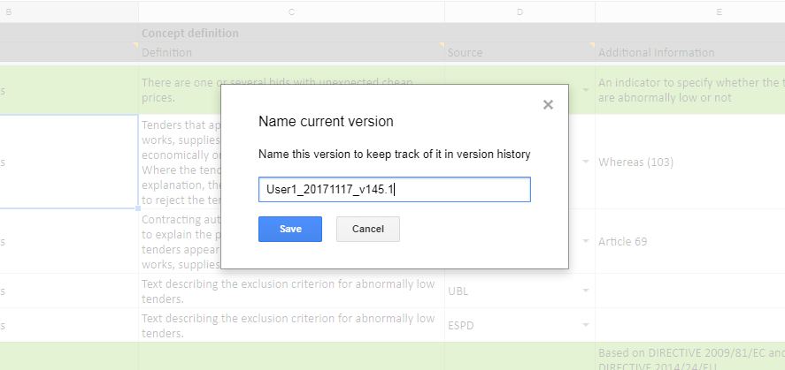
Figure 7 - Name current version

End of document

